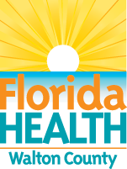Walton County Alerts
Ends: September 30, 2024

DOH-Walton Issues Mosquito-Borne Illness Alert
The Florida Department of Health in Walton County (DOH-Walton) is informing residents of two new locally-acquired West Nile virus human infections. There have been three West Nile virus infections in Walton County in 2024. DOH-Walton, South Walton County Mosquito Control District, and North Walton County Mosquito Control District are coordinating surveillance and prevention efforts by ground spraying. DOH-Walton reminds the community to avoid being bitten by mosquitoes by taking these basic precautions. The Department continues to conduct statewide surveillance for mosquito-borne illnesses, including West Nile virus infections, Eastern equine encephalitis, St. Louis encephalitis, malaria, chikungunya, and dengue. Residents of Florida are encouraged to report dead birds to the Florida Fish and Wildlife Conservation Commission’s site.

